Hey Tim,

So here’s basically what I’m trying to do. I’m looking at the cervical cancer data and regions of interest are selected by the operator based on what looks clean. It’s really ambiguous in some images and the region you select can affect the N/C ratio. I’ve been segregating the image like figure 1 shows (you can select what size circles to sample with in the program)

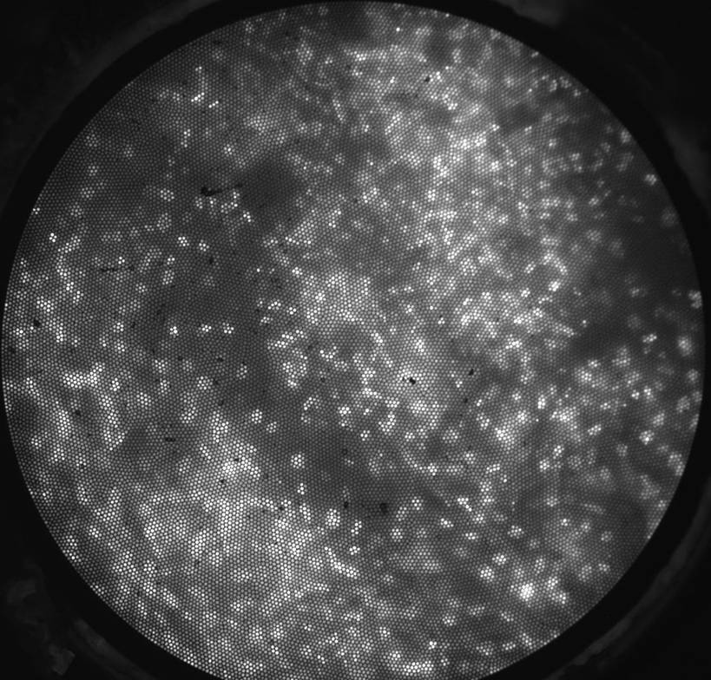

So this is the raw image

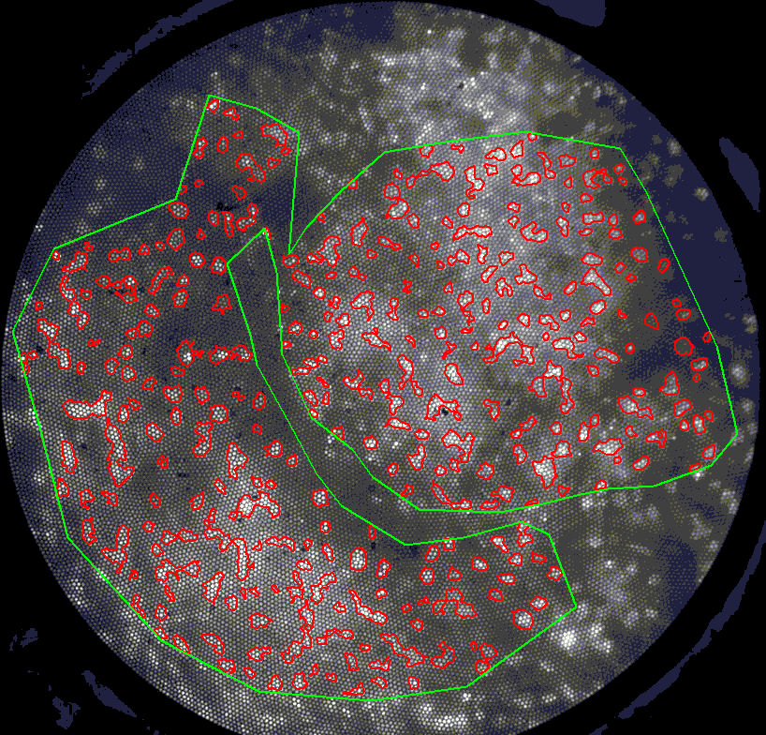

This is the ROI defined by Tefo for analysis of N/C ratio (this image is easier than most though)

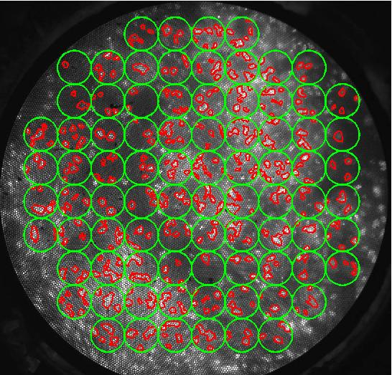

This is an example where I first segregate the image into circles of 35 pixel diameter, and calculate the N/C ratio for each

My idea was to take a bunch of samples, calculate the N/C ratio for each circle,find the mean and std, remove outlier, and then recalculate the mean. This doesn’t work very well, which I probably should have guessed. I’m wondering if there’s a better way to determine which regions aren’t good for analysis. Maybe too high of a mean intensity (indicates overexposure/excess proflavine) or too low of a mean intensity and you throw that circle out. I can’t seem to find a good cutoff though. I attached a few more with the ROI tefo/mark selected to see if you could see anything that might be easily detectable between “good” and “bad” regions. I calculated the power spectrum for each circle too which seemed like a good idea but didn’t help much. Also, I should have used squares not circles but I can fix that later

